**Index**

|  |  |  |
| --- | --- | --- |
| **Sr. No.** | **Contents** | **Page No.** |
| **1** | **Annexure I– Micro Project Proposal** | 2-3 |
| 1.Aims/Benefits of the Micro-Project | 2 |
| 2. Course Outcome Addressed | 2 |
| 3.Proposed Methodology | 2 |
| 4. Action Plan | 2-3 |
| 5. Resources Required | 3 |
| 6. Name of student with roll no | 3 |
| **2** | **Annexure II – Micro Project Report** | **4-16** |
| 1.Rationale | 4 |
| 2.Aims/Benefits of the Micro-Project | 4 |
| 3.Course Outcome Achieve | 4 |
| 4. Literature Review | 4-6 |
| 5.Source code | 6-15 |
| 6.Actual Resources Used | 15 |
| 7. Applications of this Micro-Project | 16 |

**Annexure I**

**Micro Project Proposal**

**Movie Review System**

**1. Aims/Benefits of the Micro-Project:**

To use JavaScript intrinsic function Fetch API and develop a website. Fetch is a new API that makes 'Fetching remote resources much easier. Like XMLHttpRequest, Fetch can be used for making requests same origin or cross domain requests. Fetch uses a cleaner, more powerful API that separates the request from the response and uses a promise to return the response.

**2. Course Outcome Addressed:**

1. Create interactive web page using program flow control structure.
2. Create event-based web forms using JavaScript
3. Create event-based web forms using JavaScript

d. Create interactive webpage using regular expressions for validations.

**3. Proposed Methodology:**

The [Fetch API](https://developer.mozilla.org/en-US/docs/Web/API/Fetch_API) provides a JavaScript interface for accessing and manipulating parts of the HTTP pipeline, such as requests and responses. It also provides a global [fetch()](https://developer.mozilla.org/en-US/docs/Web/API/fetch) method that provides an easy, logical way to fetch resources asynchronously across the network. This kind of functionality was previously achieved using [XMLHttpRequest.](https://developer.mozilla.org/en-US/docs/Web/API/XMLHttpRequest) Fetch provides a better alternative that can be easily used by other technologies such as [Service Workers.](https://developer.mozilla.org/en-US/docs/Web/API/Service_Worker_API) Fetch also provides a single logical place to define other HTTP-related concepts such as [CORS](https://developer.mozilla.org/en-US/docs/Web/HTTP/CORS) and extensions to HTTP.

**4. Action Plan**:

|  |  |  |  |  |
| --- | --- | --- | --- | --- |
| **Sr.**  **No.** | **Details of Activity** | **Planned**  **Start date** | **Planned**  **Finish date** | **Name of Responsible Team Members** |
| 1 | Search the topic of project | 22/08/2022  3:30 – 5:30 PM | 29/08/2022  3:30 – 5:30 PM | Khedkar Sanket Shivaji |
| 2 | Search the information about movie review | 29/08/2022  3:30 – 5:30 PM | 05/09/2022  3:30 – 5:30 PM |
| 3 | Find the list of different operations to perform | 12/09/2022  3:30 – 5:30 PM | 12/10/2022  3:30 – 5:30 PM |
| 4 | Find the information of JavaScript | 19/09/2022  3:30 – 5:30 PM | 19/09/2022  3:30 – 5:30 PM |
| 5 | Making first page | 26/09/2022  3:30 – 5:30 PM | 03/10/2022  3:30 – 5:30 PM |
| 6 | Using CSS tags to use design | 03/10/2022  3:30 – 5:30 PM | 10/10/2022  3:30 – 5:30 PM |
| 7 | Insert all the collected information | 10/10/2022  3:30 – 5:30 PM | 11/11/2022  3:30 – 5:30 PM |
| 8 | Finalizing Project with its report | 14/11/2022  3:30 – 5:30 PM | 05/12/2022  3:30 – 5:30 PM |

**5. Resources Required:**

|  |  |  |  |  |
| --- | --- | --- | --- | --- |
| **Sr.No.** | **Name of resource / material** | **Specification** | **Quantity** | **Remarks** |
| 1 | Computer | WINDOWS 7, 2GB RAM, 160GB HDD | 1 |  |
| 2 | Operating System | WINDOWS 7 | 1 |  |
| 3 | Browser | Chrome | 1 |  |

**6. Names of Team Member with Roll No.:**

|  |  |  |  |
| --- | --- | --- | --- |
| **Sr. No.** | **Enrollment No.** | **Name of Team Member** | **Roll No.** |
| 1 | 2010950092 | Khedkar Sanket Shivaji | 17 |

**Ms. Kachare S.M.**

**Name and Signature of the Teacher**

**Annexure – II**

**Micro-Project Report**

**Movie Review System**

**1. Rationale:**

JavaScript is limited featured client-side programming language. JavaScript runs at the client end through the user’s browser without sending messages back forth to the server. It is widely used by the web developers to do things such as build dynamic web pages, respond to events, create interactive forms, validates data that the visitor enters into a form, control the browser etc.

**2. Aims/Benefits of the Micro-Project:**

To use JavaScript intrinsic function Fetch API and develop a website. Fetch is a new API that makes 'Fetching remote resources much easier. Like XMLHttpRequest, Fetch can be used for making requests same origin or cross domain requests. Fetch uses a cleaner, more powerful API that separates the request from the response and uses a promise to return the response.

**3. Course Outcomes Achieved:**

a. Create interactive web page using program flow control structure.

1. Create event-based web forms using JavaScript
2. Create event-based web forms using JavaScript

d. Create interactive webpage using regular expressions for validations.

**4. Literature Review:**

DOM is a “platform- and language-neutral interface that will allow programs and scripts to dynamically access and update the content, structure and style of documents.”. The DOM stores the structure, content, style, and events that occur on a web page. The limited facilities for detecting user generated events and modifying HTML lead to the creating of ECMAScript (a standard for client-side browser scripting) in 1997. After the ECMAScript standard was released, W3C began work on standardizing the DOM for all browsers. The JavaScript API allows the web-developer to run script on the clients browser, uploaded with the web-page, to provide client side functionality, as, to reiterate from above, HTML is stateless therefore requires a full page request to perform a change, but JavaScript can alter the HTML of the page while the client is still viewing them. JavaScript has a multitude of uses, but the aspects in consideration are only a part of JavaScript, specifically its operations within the browser engine, pertaining to the window API. This is a technology that could potentially add a high quality of richness to the presentation application being designed, as manipulating the end-user’s page will provide the dynamic experience.

**5. Source code:**

**#about.html**

<html>

<div>

<head>

<link rel="icon" href="D:\js programs\New folder\images\banner.png" type="image/icon type">

<link rel="stylesheet" type="text/css" href="aboutstyle.css"></head></div>

<body background="D:\js programs\New folder\images\movie.jfif"><br/>

<script type="text/javascript">

function home(){

window.location.href="file:///D:/js%20programs/New%20folder/grid.html"

}

</script>

<div id="navlist"><center>

<nav>

<ul>

<a href="#"> Home </a>

<a href="#"> About </a>

<a href="#"> Contact </a>

<a href="#"> Terms of use </a>

<a href="#"> Join Us </a>

</ul>

</nav>

</div>

</div>

<div class="main"><center> <font color=white><h4>

Fandango is the ultimate digital network for all things movies and TV, serving more than 50 million unique visitors per month, according to comScore, with best-in-class movie and TV information, movie ticketing, trailers and original video, and home entertainment. Its portfolio features leading online ticketers Fandango, MovieTickets.com and Flixster; world-renowned entertainment review site Rotten Tomatoes; and Movieclips, the #1 movie trailers and content channel on YouTube. Fandango's on-demand streaming service, Vudu, offers over 200,000 new release and catalog movies and next-day TV shows to more than 200 million connected, over-the-top (OTT) and mobile devices.</h4>

<img src="D:\js programs\New folder\images\wall e.jfif" alt="custom_html_banner" width= "50%" height="480" name="ChangeBanner"><br>

<br><input type="button" name="start" value="Start" width="250px" height="250px" onclick="home()">

</center>

</div>

</body>

</body>

</html>

#Output

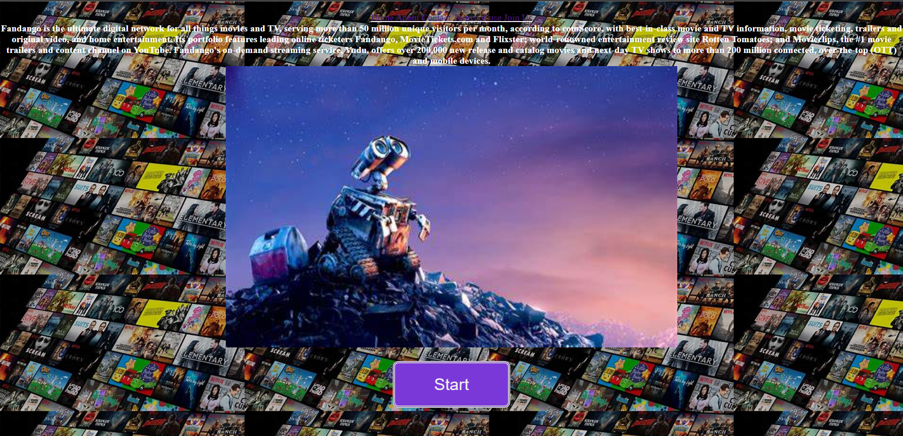

**#Main.html**

<!DOCTYPE html>

<html>

<head>

<meta charset="utf-8">

<meta name="viewport" content="width=device-width, initial-scale=1">

<title>Movie Review</title>

<link rel="stylesheet" type="text/css" href="sty.css">

<nav>Login</nav>

</head>

<body>

<nav>

<input type="button" name="Login" id="check1" onclick="home()">

<input type="radio" name="photos" id="check2">

<input type="radio" name="photos" id="check3">

<input type="radio" name="photos" id="check4">

</nav>

<div class="container">

<h1>Movie review</h1>

<div class="top-content">

<h3>movies</h3>

<label for="check1">Login</label>

<label for="check2">About us</label>

<label for="check3">Upcoming movies</label>

<label for="check4">top this week</label>

</div>

<div class="us">

<h2>Read everything under the sun</h2>

<p>This is your source for movie reviews and movie ratings to help maximize your movie-going-experience. Our easy to use movie reviews and movie ratings are based on scores and opinions from respected movie critics, family advocacy groups and movie fans like you. Whether it’s a family movie outing, first date or girls’ night out, our movie reviews will help you find the perfect movie for any occasion.</p>

</div>

<div class="slideshow-container">

<div class="mySlides fade">

<div class="numbertext">1 / 3</div>

<img src="D:\js programs\New folder\images\OIP.jpeg" style="width:100%">

<div class="text"></div>

</div>

<div class="mySlides fade">

<div class="numbertext">2 / 3</div>

<img src="D:\js programs\New folder\images\Black-Panther.jpeg"style="width:100%">

<div class="text"></div>

</div>

<div class="mySlides fade">

<div class="numbertext">3 / 3</div>

<img src="D:\js programs\New folder\images\1899.jpeg" style="width:100%">

<div class="text"></div>

</div>

<!-- Next and previous buttons -->

<a class="prev" onclick="plusSlides(-1)">&#10094;</a>

<a class="next" onclick="plusSlides(1)">&#10095;</a>

</div>

<br>

<div style="text-align:center">

<span class="dot" onclick="currentSlide(1)"></span>

<span class="dot" onclick="currentSlide(2)"></span>

<span class="dot" onclick="currentSlide(3)"></span>

</div>

<div class="movie">

<div class="select">

<img src="C:\Users\SANKET\Downloads\8 miles.jpeg"alt="movie">

<p>8 Mile is a 2002 American drama film written by Scott Silver and directed by Curtis Hanson. It stars Eminem in his film debut, alongside Mekhi Phifer, Brittany Murphy, Michael Shannon, Anthony Mackie, and Kim Basinger.</p>

<a href="https://www.imdb.com/title/tt0298203/reviews">read more</a>

</div>

<div class="select 1">

<img src=C:\Users\SANKET\Downloads\avengers.jpeg alt="Latest">

<p>The Avengers and their allies must be willing to sacrifice all in an attempt to defeat the powerful Thanos before his blitz of devastation and ruin puts an end to the universe.</p>

<a href="https://www.imdb.com/title/tt4154756/reviews/?ref_=tt_ql_urv">read more</a>

</div>

<div class="select 2">

<img src=C:\Users\SANKET\Downloads\cpfa.jpeg alt="Upcoming">

<p>Steve Rogers, a rejected military soldier, transforms into Captain America after taking a dose of a "Super-Soldier serum". But being Captain America comes at a price as he attempts to take down a warmonger and a terrorist organization</p>

<a href="https://www.imdb.com/title/tt0458339/reviews/?ref_=tt_ql_urv">read more</a>

<span class="fa fa-star checked"></span>

<span class="fa fa-star checked"></span>

<span class="fa fa-star checked"></span>

<span class="fa fa-star"></span>

<span class="fa fa-star"></span>

</div>

</div>

</div>

<div class="wrapper">

<div class="sidebar">

<div class="profile">

</div>

</div>

</div>

<div class="footer">

<hr>

</div>

<script type="text/javascript">

function home()

{

let url ="web.html";

window.open(url);

}

let slideIndex = 0;

showSlides();

function showSlides() {

let i;

let slides = document.getElementsByClassName("mySlides");

for (i = 0; i < slides.length; i++) {

slides[i].style.display = "none";

}

slideIndex++;

if (slideIndex > slides.length) {slideIndex = 1}

slides[slideIndex-1].style.display = "block";

setTimeout(showSlides, 5000); // Change image every 2 seconds

}

</script>

</body>

</html>

#Output

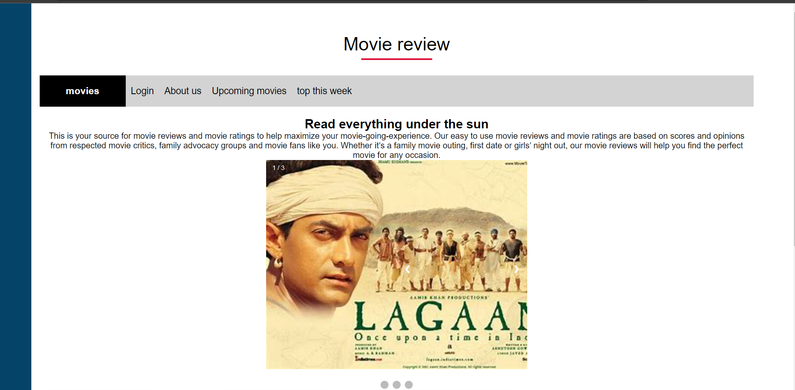

**#Login.html**

<html>

<head>

<meta charset="utf-8">

<title>Sanket Khedkar</title>

</head>

<font color="#A6ACAF" size="5">

<marquee><b><i>Login to continue</i></b></marquee>

</font>

<body background="D:\js programs\New folder\images\wall e.jfif" link="white" alink="black" vlink="#3e3ed4" style="background-color:white;">

<br />

<center>

<article>login in to get access to review comments<br> HTml and css </article><br>

</center>

<font face="cinzel" size="4">

<center>

<form>

<label for="fname">First Name:</label>

<input type="text" id="fname" name="fname"><br>

<label> <b>Password</b> </label>

<input type="password" name="" value=""/required>

<button>Click me</button>

</form>

</center>

</font>

<br /><br /><br /><br />

<br />

<br />

<h1 align="center">

<font color="#e2d604" size="4" >

WELCOME TO LOGIN PAGE<br/>

</font>

START OF A JOURNEY

</h1>

<hr>

<details>My name is Sanket Khedkar i designed this web page using Html and css</details>

<details>this toggle button describes the way we can decide to view or hide the information</details>

</body>

</html>

#Output

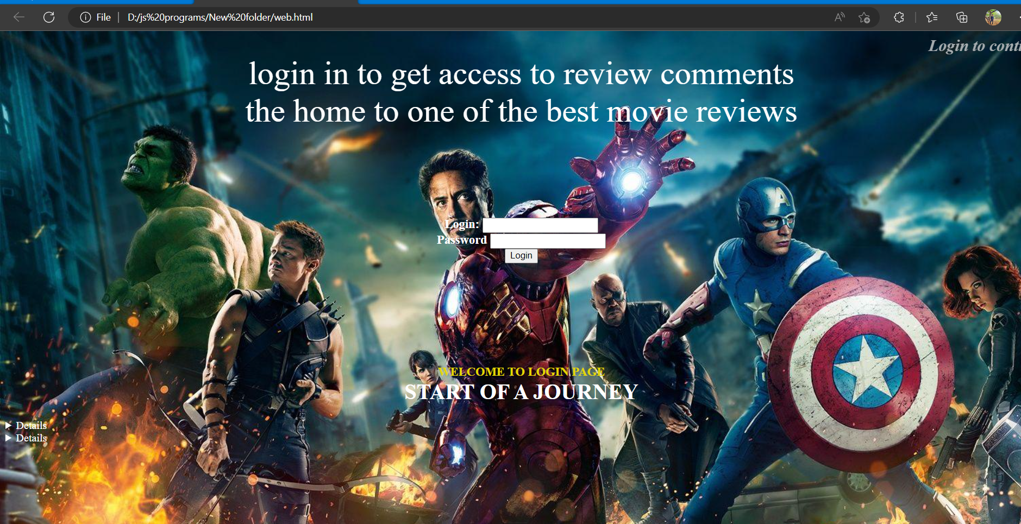

**6. Actual Resources Used:**

|  |  |  |  |  |
| --- | --- | --- | --- | --- |
| **Sr.**  **No.** | **Name of resource / material** | **Specification** | **Quantity** | **Remarks** |
| 1 | Computer | WINDOWS 7,2GB RAM, 160GB HDD | 1 |  |
| 2 | Operating System | WINDOWS 7 | 1 |  |
| 3 | Browser | Chrome | 1 |  |

**7. Skill developed / Learning out of this Micro-Project:**

I learnt from this project that what is API, how to use fetch API method for getting response from the server, what is async and await in JavaScript and mainly I learnt that asynchronies nature of JavaScript.

**8. Applications of this Micro-Project:**

User can use this project to update, upload or load movie reviews so it gives rating on how the movie and if you are thinking to watch it then see if it’s worth.

*********